**Comparison of Restaurant Presence in Toronto and Lexington, Kentucky**

**Introduction**

People who live near Lexington, Kentucky often note that it seems to have a large number of restaurants for its population. How does it compare to a much larger city? Toronto has more than 9 times the population of Lexington, so it would be interesting to see how the cities compare in the number and variety of restaurants. This can be examined from several different perspectives. How does the raw number of restaurants compare between the two cities? How does the number of restaurants per capita compare? What kind of restaurants are present in each city? In short, is Lexington truly a 'restaurant town' or is it simply in line with cities like Toronto?

The results of this investigation should interest several different audiences. Entrepreneurs can see whether Lexington is a good place to start restaurants. Food tourists can understand if Lexington is worth a trip. Residents and leaders of both cities can learn more about this aspect of their city's culture. Are certain parts of Lexington particularly good for certain types of restaurants? Are there areas of town which lack a particular genre of food?

**Data**

To explore these questions, I will use venue data from Foursquare.com as well as population data from Wikipedia. Foursquare provides a list of names and types of restaurants. Lexington neighborhoods are best found on various realty sites. The geographic coordinates for Lexington neighborhoods came from Google. For Toronto, this information was provided by the class.

K-means clustering was used to identify the types of restaurants with particular neighborhoods. Along the way, maps helped to form an image of the clusters.

**Methodology**

Figure 1 describes how this project was executed. The first challenge was obtaining a list of neighborhoods for Toronto and Lexington. The unreliability of the various websites forced me to pull the data from Wikipedia and other websites rather than scraping them from the web. Similar issues required the same solution for obtaining the geospatial coordinates for the neighborhoods and the cities. However, Foursquare proved to be both stable and accurate and allowed the project to collect data on venues.

Since Foursquare provides information on may different kinds of venues, it was necessary to limit the list to restaurants. This was not as simple as selecting the rolls which included the word restaurant because this would leave out several different items. An examination of the venue category list showed the potential restaurant types shown in Table 1.



Figure 1: Project flow chart

Table 1: List of possible restaurant types

|  |  |  |  |
| --- | --- | --- | --- |
| Afghan Restaurant | American Restaurant | Asian Restaurant | BBQ Joint |
| Bed & Breakfast | Belgian Restaurant | Brazilian Restaurant | Breakfast Spot |
| Burger Joint | Café | Caribbean Restaurant | Chinese Restaurant |
| Colombian Restaurant | Comfort Food Restaurant | Diner | Doner Restaurant |
| Dumpling Restaurant | Eastern European Restaurant | Empanada Restaurant | Ethiopian Restaurant |
| Falafel Restaurant | Fast Food Restaurant | Filipino Restaurant | French Restaurant |
| Fried Chicken Joint | Gaming Cafe | Gastropub | German Restaurant |
| Gluten-free Restaurant | Greek Restaurant | Hotpot Restaurant | Indian Restaurant |
| Italian Restaurant | Japanese Restaurant | Korean Restaurant | Latin American Restaurant |
| Mediterranean Restaurant | Mexican Restaurant | Middle Eastern Restaurant | Modern European Restaurant |
| Molecular Gastronomy Restaurant | New American Restaurant | Pizza Place | Polish Restaurant |
| Portuguese Restaurant | Ramen Restaurant | Restaurant | Sandwich Place |
| Seafood Restaurant | Sushi Restaurant | Taiwanese Restaurant | Thai Restaurant |
| Theme Restaurant | Vegetarian / Vegan Restaurant | Vietnamese Restaurant | Wings Joint |

The restaurant names and types were added to the database. Now there was enough data to look at each neighborhood. First, the code counted the number of restaurants for each city, noting that Toronto has more than 9 times the population of Lexington. It was also important to examine the different categories of restaurants present in each city. Finally, the 10 most common restaurant types were listed for each neighborhood.

Finally, a K-means cluster analysis segmented the data into reasonable clusters. Toronto, being a larger city, had two more clusters than the 3 clusters used for Lexington. These clusters were placed on the maps of cities.

**Results**

The first question addressed by this study was whether Lexington had an inordinate number of restaurants for its size. Foursquare identified 479 restaurants in Toronto and 49 in Lexington. Since Toronto has 9.1 times the number of people as Lexington, we would expect to find around 52 restaurants in the latter city. This is pretty close to the expected number, so we can say that Lexington has a comparable food scene to Toronto in terms of the number of places to eat per capita. That’s not the only way to evaluate a food scene, however. Lexington has only 14 types of restaurant while Toronto has a remarkable 56. Thus, there is far more variety of options in Toronto.

The K-Means clustering algorithm was also revealing. Toronto’s neighborhoods were divided into 5 different groups as shown in Table 2. Several categories were common in most clusters, notably general restaurants, cafes, and Japanese restaurants. The map in figure 2 shows how the clusters are roughly defined by distance from the University of Toronto.

Table 2: Clustering for downtown Toronto

|  |  |  |  |  |  |  |  |  |  |  |
| --- | --- | --- | --- | --- | --- | --- | --- | --- | --- | --- |
| **Neighbourhood** | **1st Most Common Venue** | **2nd Most Common Venue** | **3rd Most Common Venue** | **4th Most Common Venue** | **5th Most Common Venue** | **6th Most Common Venue** | **7th Most Common Venue** | **8th Most Common Venue** | **9th Most Common Venue** | **10th Most Common Venue** |
| Harbourfront,Regent Park | Restaurant | Café | Mexican Restaurant | Asian Restaurant | French Restaurant | Breakfast Spot | Wings Joint | Doner Restaurant | Fried Chicken Joint | Filipino Restaurant |
| Ryerson,Garden District | Middle Eastern Restaurant | Japanese Restaurant | Café | Restaurant | Diner | Italian Restaurant | Pizza Place | Ramen Restaurant | Fast Food Restaurant | Sandwich Place |
| St. James Town | Restaurant | Café | Italian Restaurant | Diner | Breakfast Spot | American Restaurant | Thai Restaurant | Gastropub | BBQ Joint | Seafood Restaurant |
| Berczy Park | Restaurant | Seafood Restaurant | Café | Japanese Restaurant | Eastern European Restaurant | Breakfast Spot | Greek Restaurant | French Restaurant | BBQ Joint | Thai Restaurant |
| Central Bay Street | Italian Restaurant | Japanese Restaurant | Sandwich Place | Burger Joint | Café | Middle Eastern Restaurant | Chinese Restaurant | Thai Restaurant | Seafood Restaurant | Sushi Restaurant |

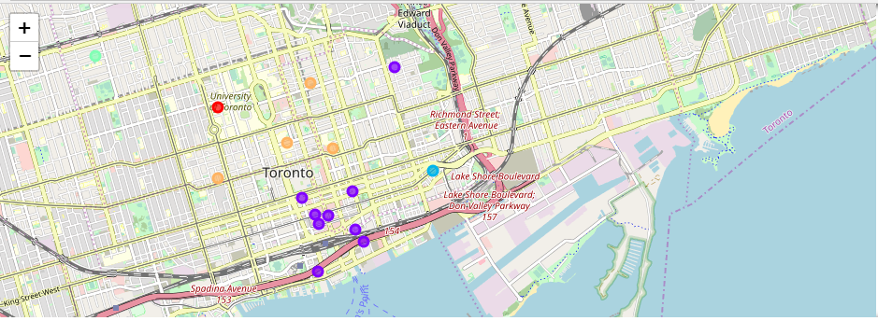

Figure 2: Map of downtown Toronto with clusters

Because Lexington is so much smaller, it could be divided into a maximum of 3 clusters. Table 3 shows how vegetarian restaurants and sandwich places were common in each cluster. The cluster centroids are spread much further apart than Toronto, most likely a result of the considerably smaller population density in Lexington.

Table 3: K-Means clusters for Lexington

|  |  |  |  |  |  |  |  |  |  |  |
| --- | --- | --- | --- | --- | --- | --- | --- | --- | --- | --- |
| **Neighborhood** | **1st Most Common Venue** | **2nd Most Common Venue** | **3rd Most Common Venue** | **4th Most Common Venue** | **5th Most Common Venue** | **6th Most Common Venue** | **7th Most Common Venue** | **8th Most Common Venue** | **9th Most Common Venue** | **10th Most Common Venue** |
| Central Downtown | Vegetarian / Vegan Restaurant | Sandwich Place | Pizza Place | Molecular Gastronomy Restaurant | Latin American Restaurant | Hot Dog Joint | Gastropub | French Restaurant | Diner | Café |
| Eastland | Restaurant | Vegetarian / Vegan Restaurant | Sandwich Place | Pizza Place | Molecular Gastronomy Restaurant | Latin American Restaurant | Hot Dog Joint | Gastropub | French Restaurant | Diner |
| Southern Park | Diner | Vegetarian / Vegan Restaurant | Sandwich Place | Restaurant | Pizza Place | Molecular Gastronomy Restaurant | Latin American Restaurant | Hot Dog Joint | Gastropub | French Restaurant |

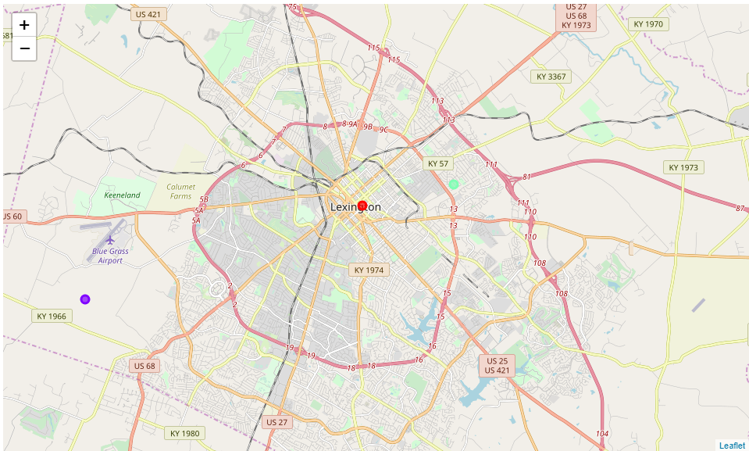

Figure 3: Map of clusters in Lexington

It’s important to note that several neighborhoods in Lexington lacked restaurants in the Foursquare database. This reduced the number of available clusters and most likely under-reported the number of restaurants there.

**Discussion**

These results are quite interesting. Looking at the analysis in one way, Lexington has a similar number of restaurants as Toronto when taking into account the different population sizes. It’s important to note that Foursquare was missing data for several Lexington neighborhoods and a case might still be made for it having more restaurants per person. In any case, Lexington has much less variety than Toronto. Thus, eating establishments are quite as available in Lexington as Toronto, but the choices of types of restaurant is limited.

The cluster list for Lexington was quite interesting. First, it’s surprising how many vegetarian restaurants are present in a southern US city. Pizza places were further down the list and an investor might be wise to open a pizza parlor in Southern Park since Lexington appears to like its pizza and this neighborhood seems to lack such restaurants in comparison to its neighbors.

**Conclusions and recommendations for future work**

The data seem to indicate that Lexington is indeed a city with an active food scene, though it differs in many ways from Toronto. Toronto has many ethnic restaurants which do not exist at all in Lexington. If one is vegetarian, however, Lexington might be the place to visit on a food tour.

This analysis begs for more work. In particular, how do other cities compare to Lexington? Also, why does Foursquare fail to list any restaurants at all for several Lexington neighborhoods?